**Lab 8: TCP**

University of Windsor

Department of Electrical and Computer Engineering

ELEC 8560 – Computer Networks

Semester: Fall 2023

**Student Name**: Amey Mahendra Thakur

**Student number**: 110107589

**Answers:**

1. Client’s IP address is **192.168.2.95** and the TPC port number is **50533**.

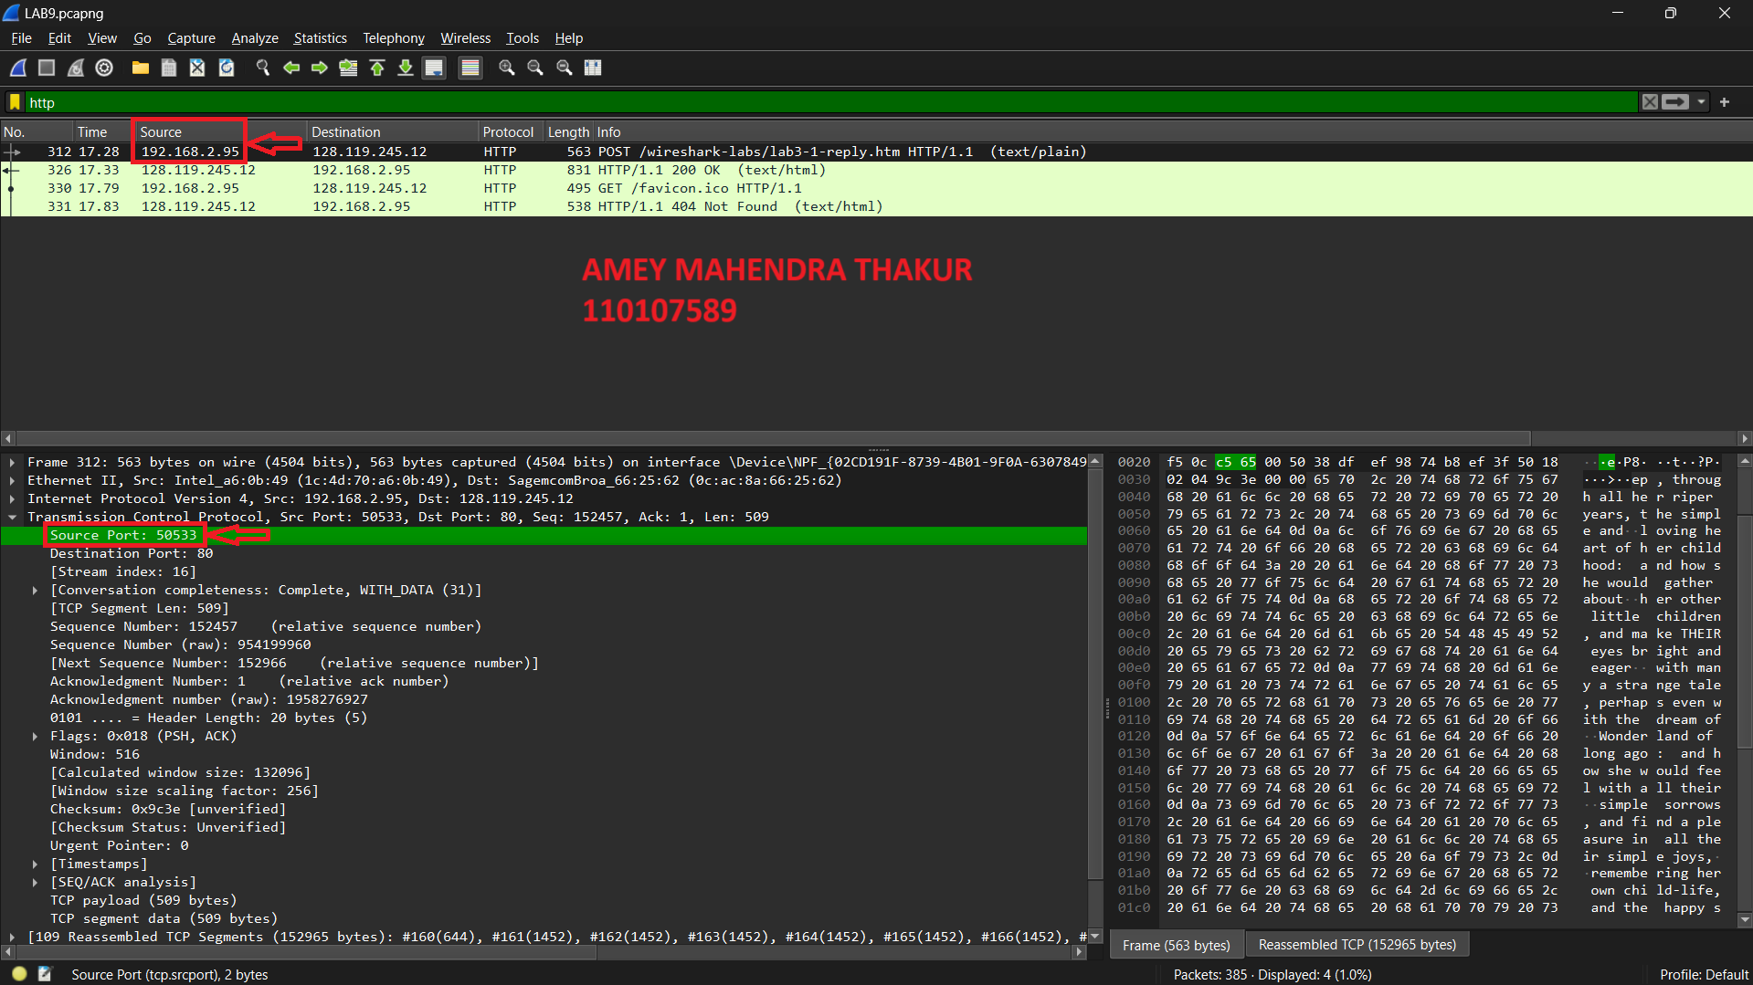

1. The IP address of gaia.cs.umass.edu is **128.119.245.12** and the TCP port number is **80**.

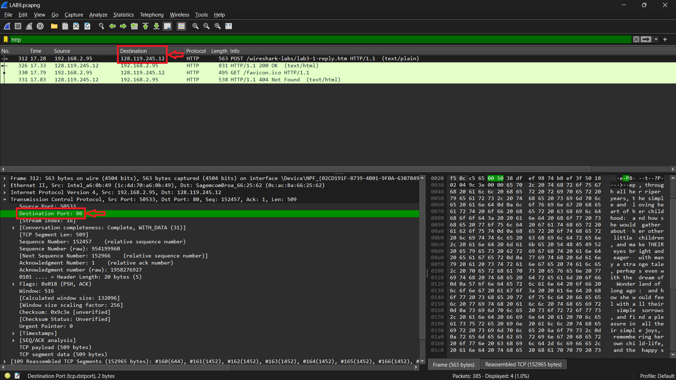

1. The sequence number of the TCP SYN segment is **954047503.** since it is used to imitate the TCP connection between the client computer and gaia.cs.umass.edu.

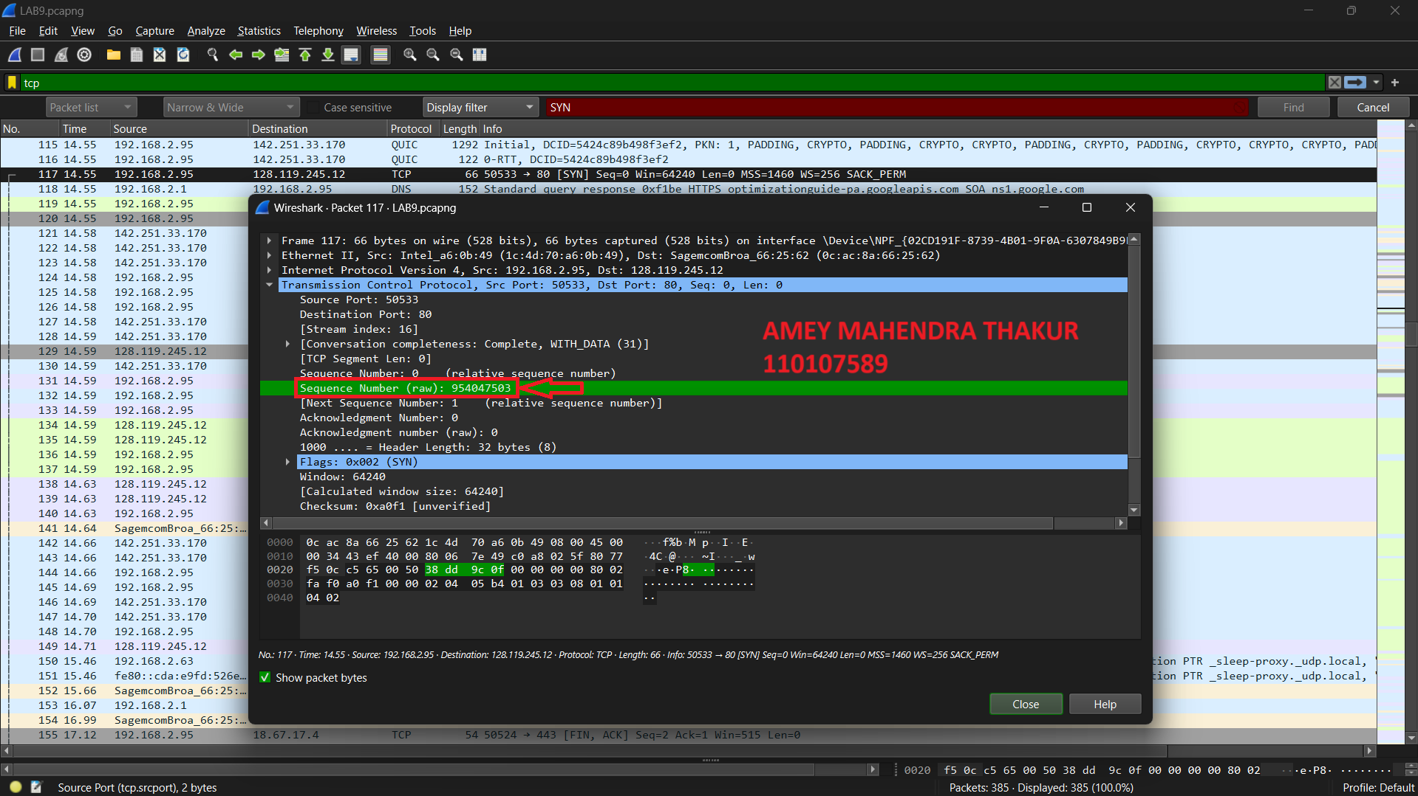

1. The Flags section, the **Syn flag is set to 1** which indicates that this segment is a SYN segment. The TCP receiver in this session **will be able to** use Selective Acknowledgments.

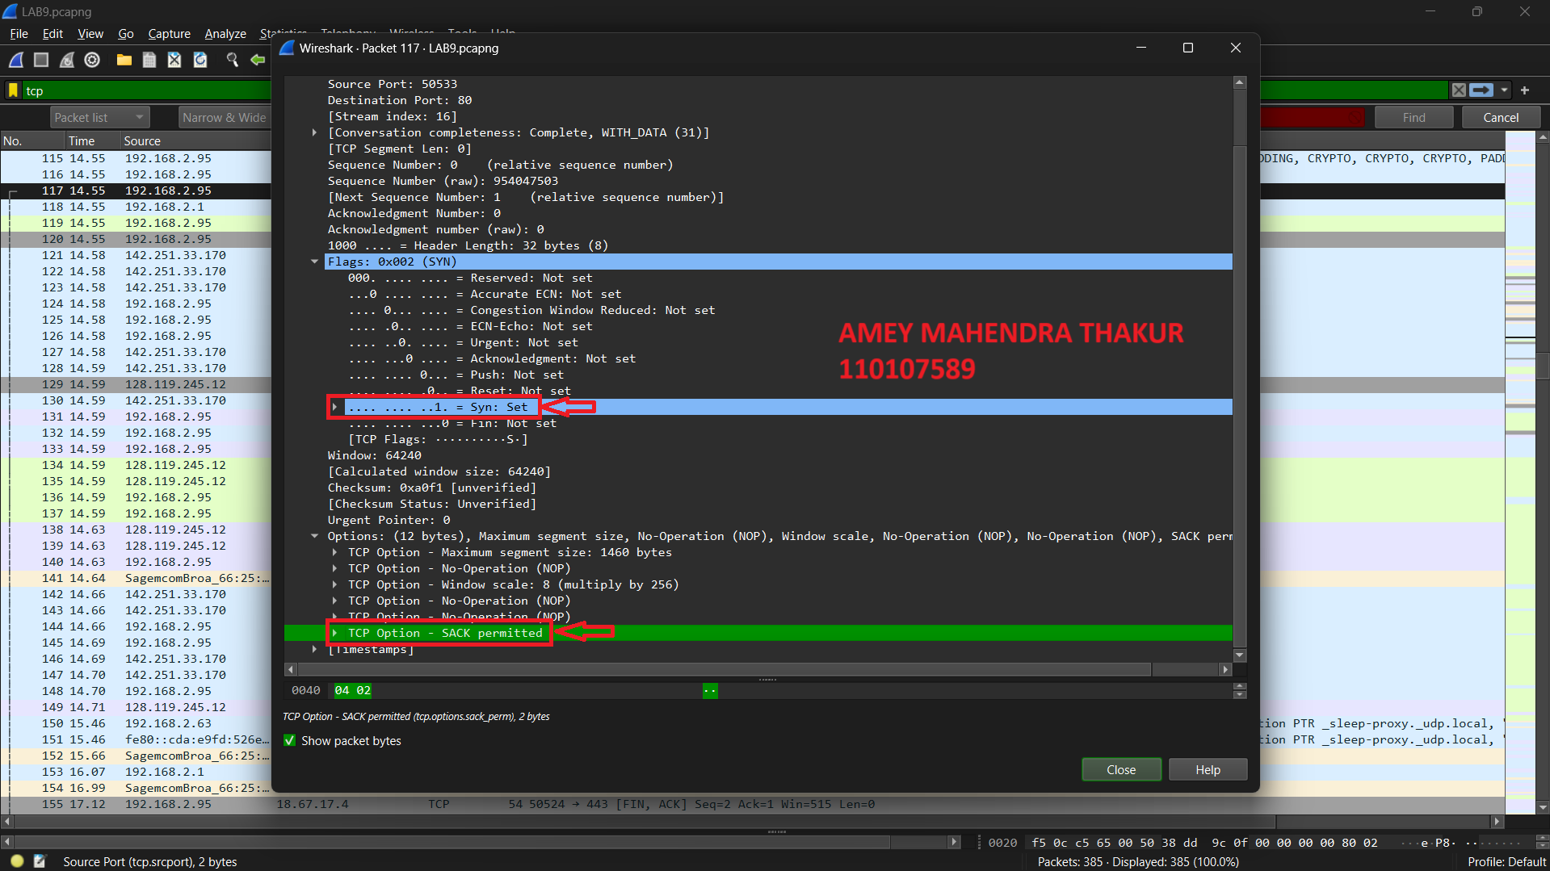

1. The sequence number of the SYNACK segment sent by gaia.cs.umass.edu to the client computer in reply to the SYN is **1958276926.** The value of the acknowledgement field in the SYNACK segment is 1. The value of the Acknowledgement field in the SYNACK segment is determined by the server gaia.cs.umass.edu. The server adds 1 to the initial sequence number of SYN segment form the client computer.

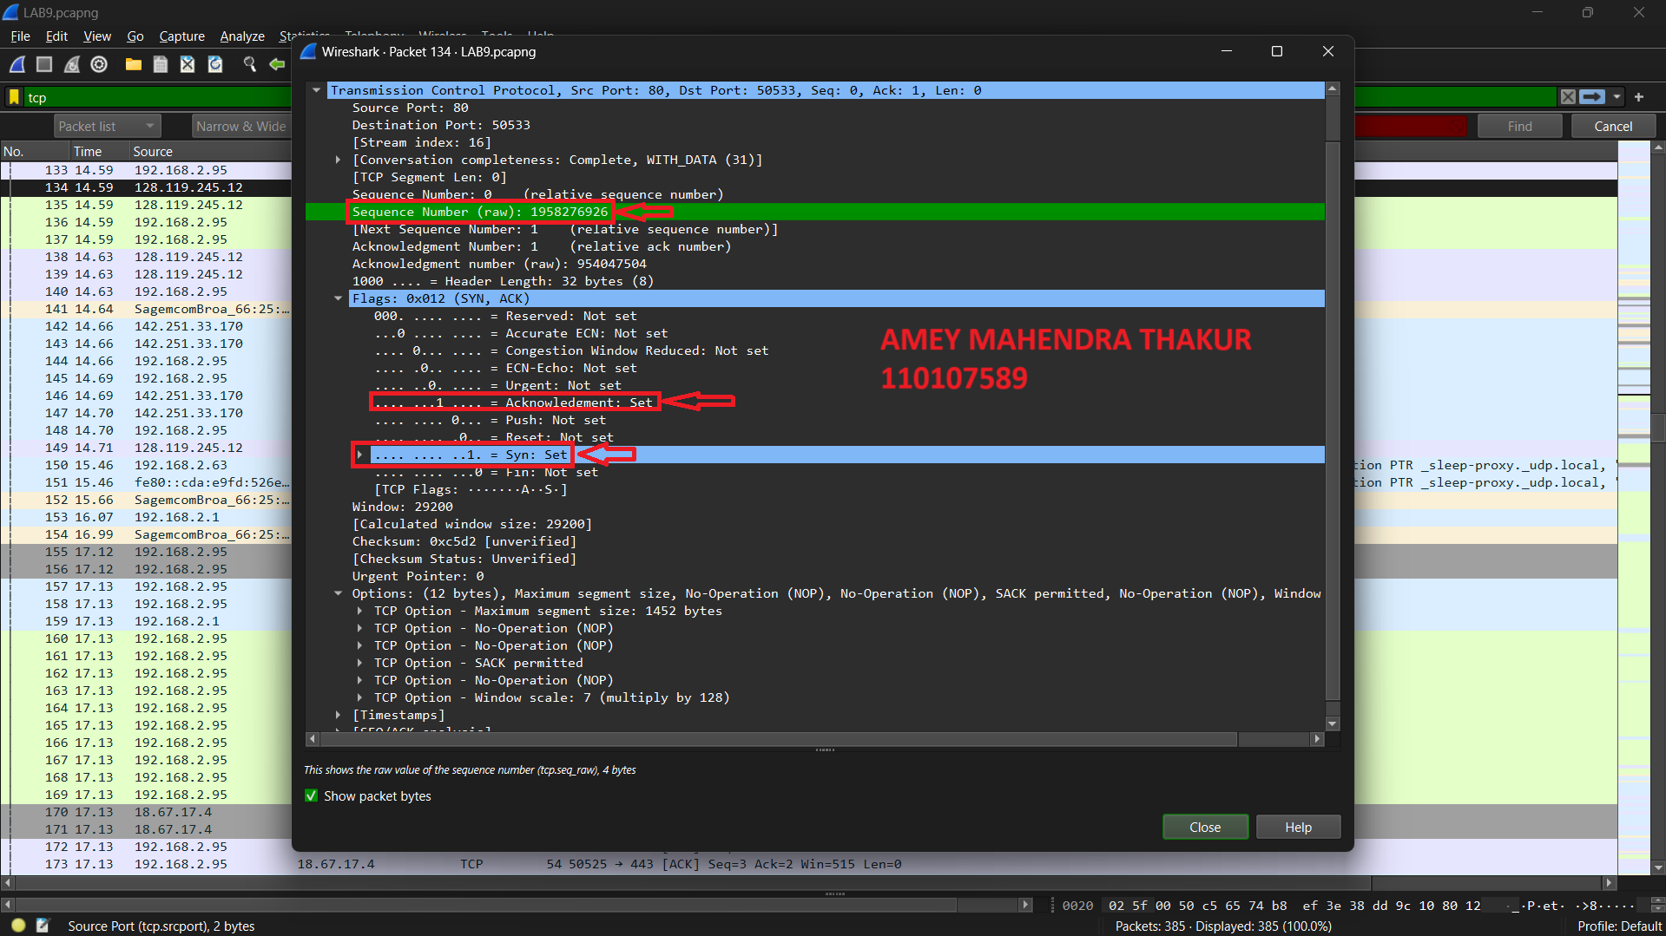

1. The sequence number of the TCP segment containing the header of the HTTP POST command is **954047504.** The bytes of data are contained in the payload (data) field of this TCP segment is **644 Bytes.** The data that we transferred cannot fit into a single segment as a TCP segment can only take 64KBytes of data but our file is about 150KBytes.

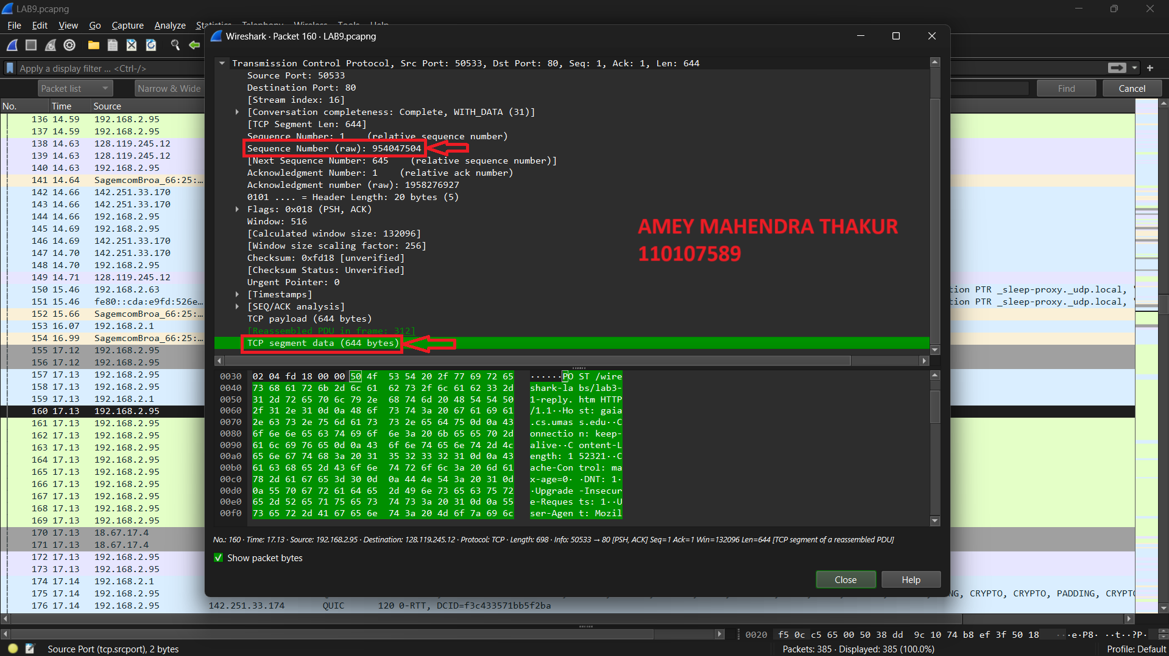

1. The first segment in the data transfer part of the TCP connection has been sent at **2.580842000 seconds.**

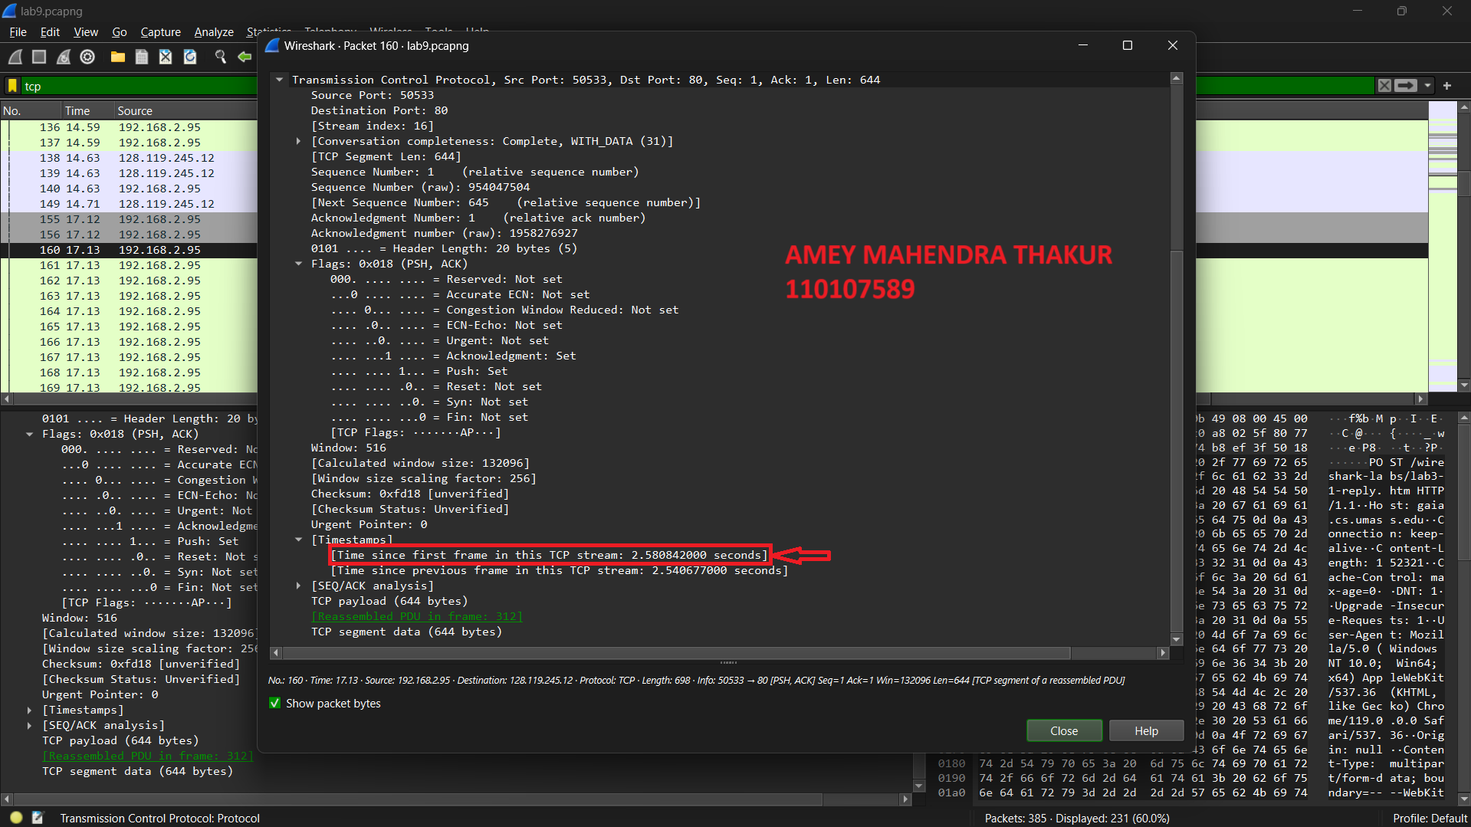

1. The length of first packet is **684 Bytes** and the rest of the three packets is **1492 Bytes.**

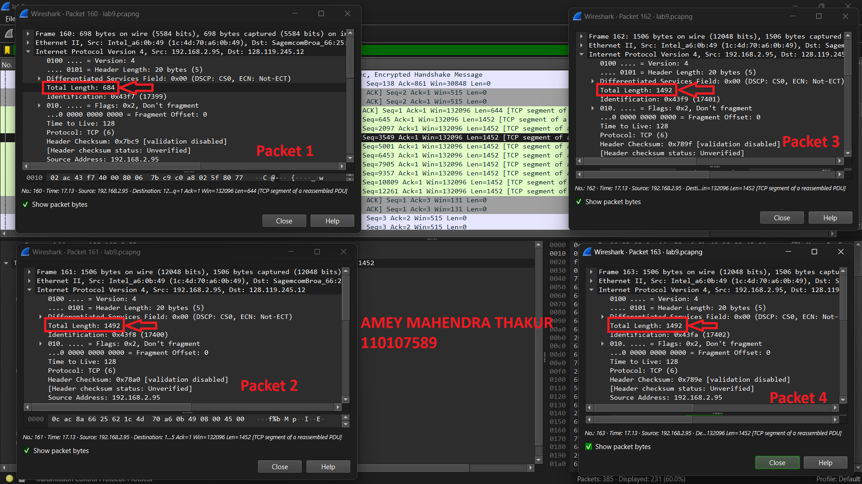

1. The minimum amount of available buffer space advertised at the received for the first four data-carrying TCP segments, its value is **29200 Bytes.** The lack of receiver buffer space **never throttled** the sender for these first four data-carrying segments.

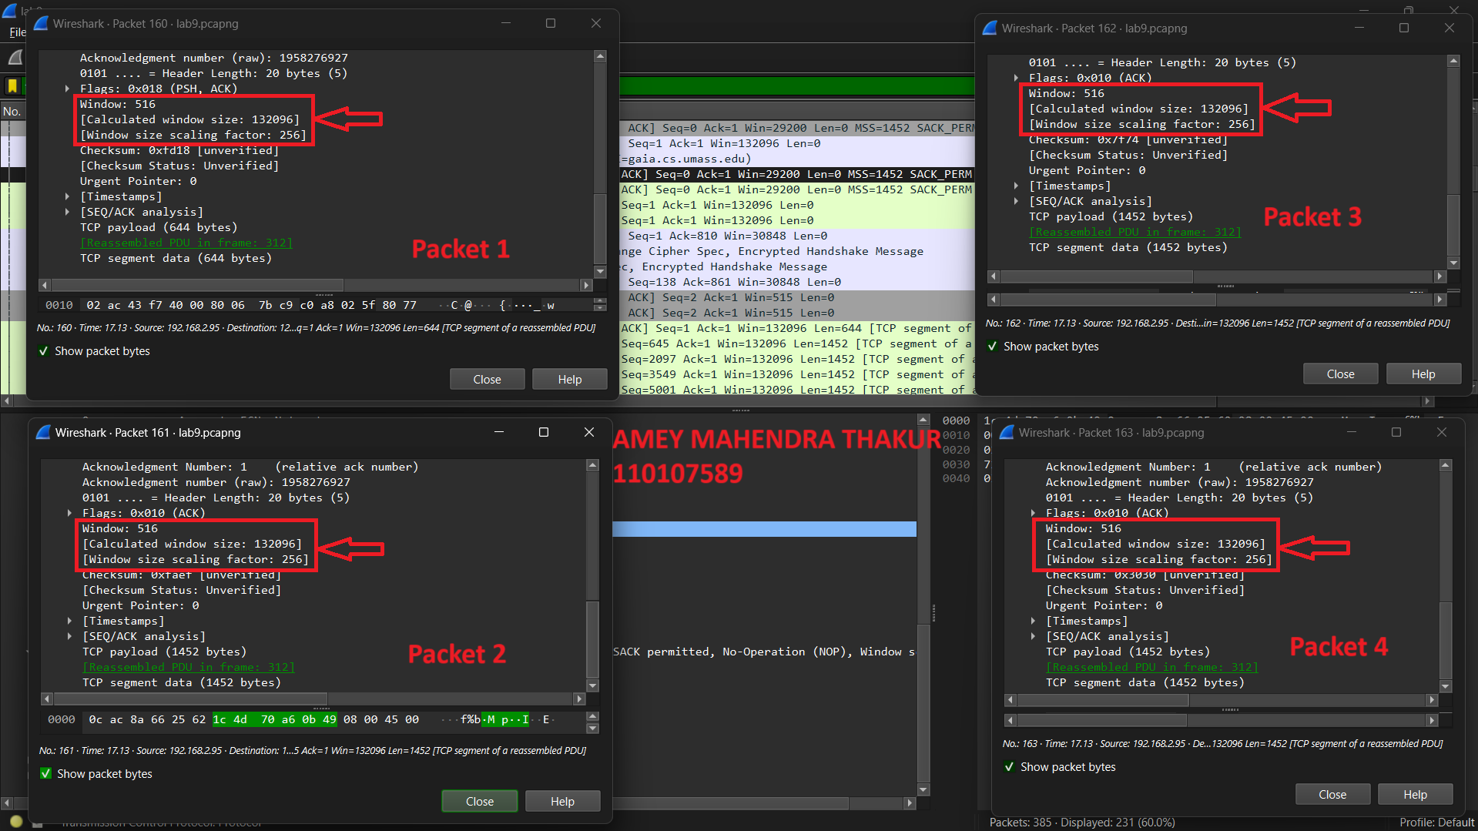

1. There are no re-transmitted segments in the trace file. By checking the TCP segment’s Sequence Number in the trace file, we can verify it. In Time-Sequence-Graph (Stevens) belonging to this trace, all the sequence numbers from the Source to the Destination are monotonically increasing with respect to time. The Sequence Number of any retransmitted segments must be lower than the neighboring segments if there are any.

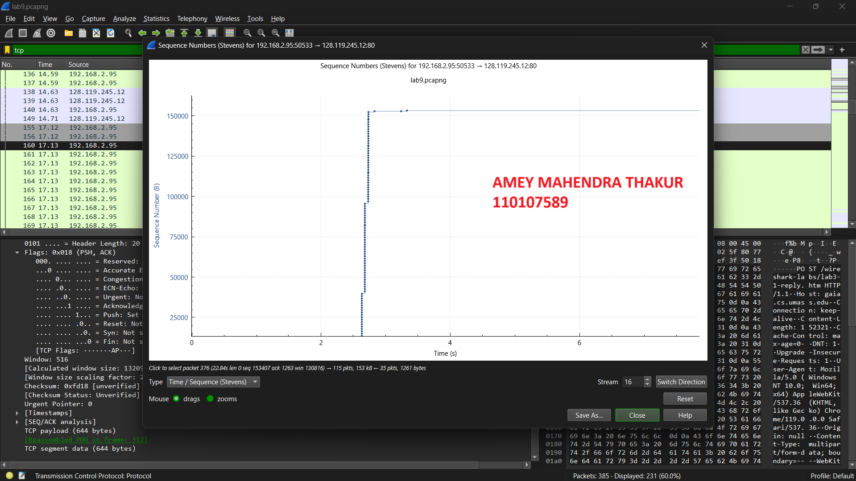

1. Among the first 10 data-carrying segments sent from the client to gaia.cs.umass.edu, the receiver acknowledges 1452 bytes in an ACK. There are instances where the receiver is Acknowledging every other segment, as can be seen by looking at the amount of acknowledged data by each ACK.

| **ACKNOWLEDGEMENT** | **ACKNOWLEDGED SEQUENCE NUMBER** | **ACKNOWLEDGED DATA** |
| --- | --- | --- |
| ACK1 | 1 | 644 |
| ACK2 | 645 | 1452 |
| ACK3 | 2097 | 1452 |
| ACK4 | 3549 | 1452 |
| ACK5 | 5001 | 1452 |
| ACK6 | 6453 | 1452 |
| ACK7 | 7905 | 1452 |
| ACK8 | 9357 | 1452 |
| ACK9 | 10809 | 1452 |
| ACK10 | 12261 | 1452 |

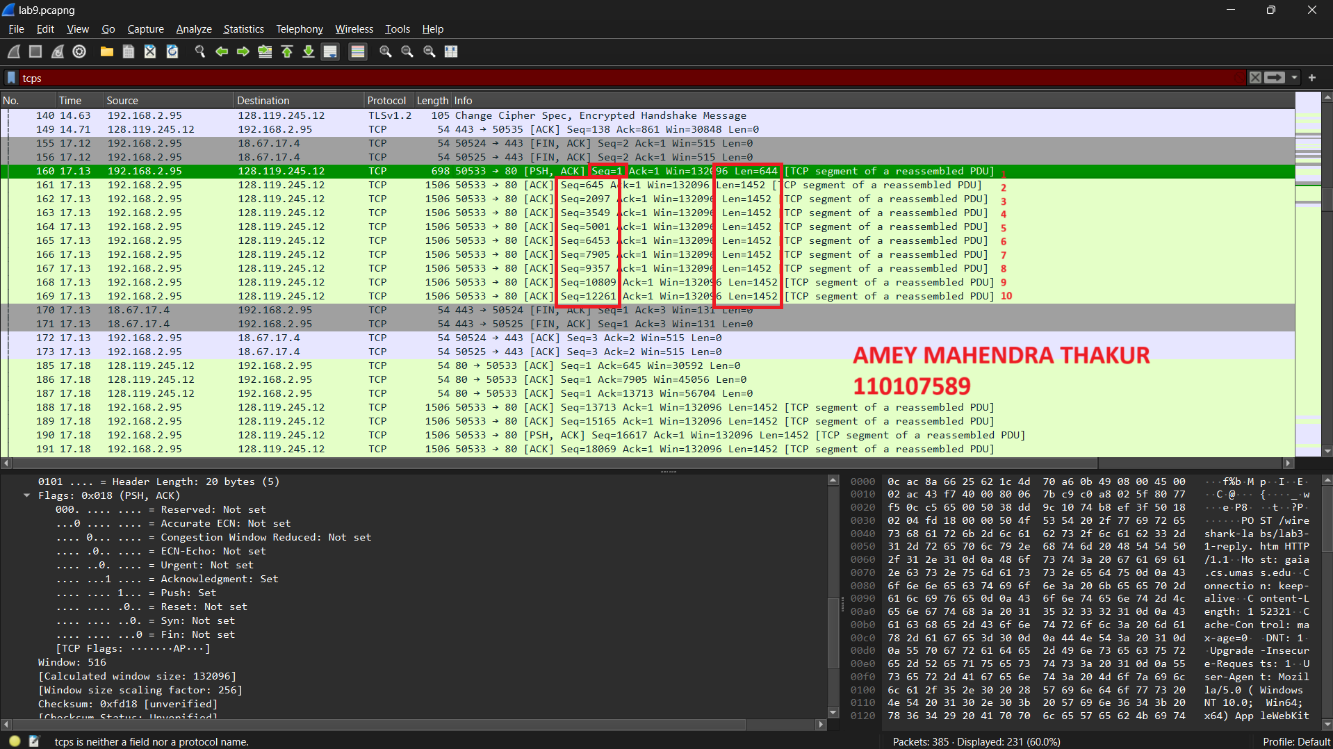

1. The visualization that we obtained from Time-Sequence(stevens) graph is:



1. The slow start of the TCP seems to begin at about 2.6 seconds and then ends at about 2.8 seconds. Congestion avoidance takes over at about 3.2 seconds because it cut down the amount being sent:

| **Phase** | **Strating (Approx)** | **Ending (Approx)** |
| --- | --- | --- |
| Slow start phase | 2.6 s | 2.8 s |
| Congestion avoidance phase | 3.2 s | end |

1. A fleet of segments appears consistently at regular intervals for a few seconds, then starts increasing again.